

Feature detection and matching

ub | Facultat de Matemàtiques i Informàtica

Computer vision – lab 3

josep famadas alsamora / jordi riu vicente

2017

Table of contents

Table of Figures 2

1- Feature detection 3

# Table of Figures

Figure 1: SIFT features on a grayscale image 3

Figure 2: SIFT features with different DoG thresholds 4

Figure 3: SIFT features with different Edge thresholds 5

# Feature matching

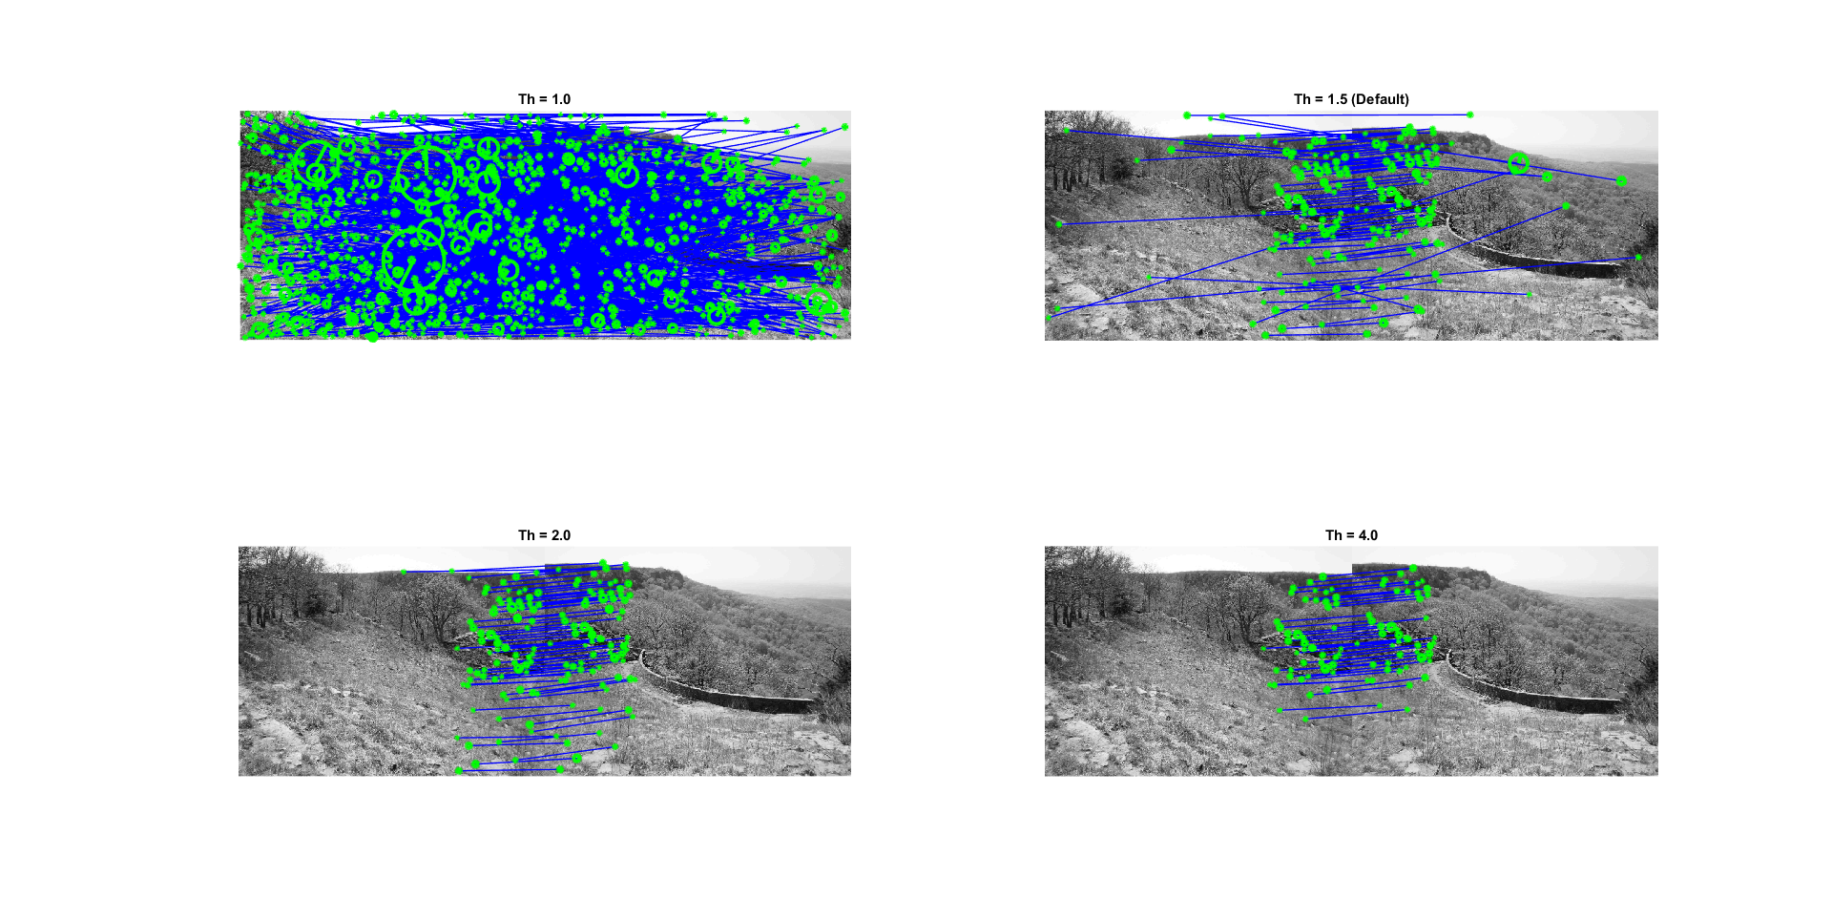

Question 1:

The ubcmatch function matches a keypoint of an image with the one from the other image that is most similar to it (minimum distance between them). Even if a keypoint has no match on the other image, the function will find a mismatch for it, so to make sure that the match of two keypoints is a true match we define a threshold. The threshold ensures that the distance between a keypoint and its closest match and between the same keypoint and its second closest match follows:

If this relation is satisfied, the match is taken as a true match. As we can observe in *Figure 1*, as it was expected, the higher the threshold, the more restrictive are the matches.

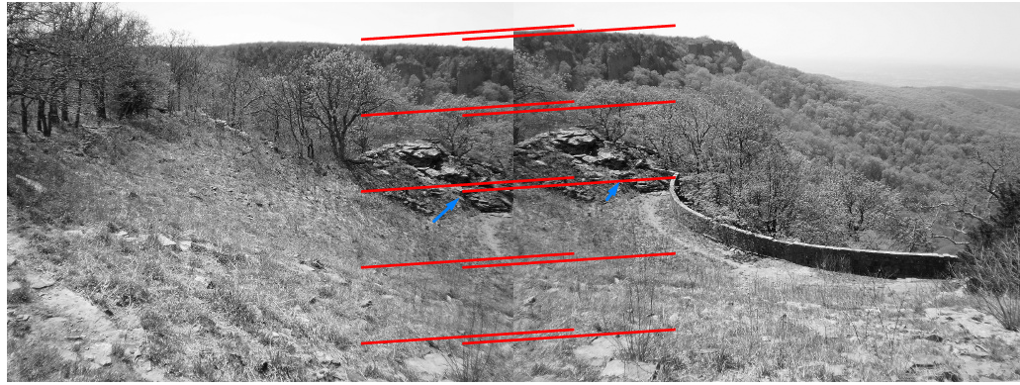

Question 2:

We can appreciate in *Figure 2* that a linear translation computed with the default threshold is not really good, for example, one can appreciate the blue arrows that signal the same point in both images but they are not connected by the model.

On the other hand, if we compute the linear model taking into account only the best matches (the ones obtained with a threshold of 4 in the previous question) the results are far better.

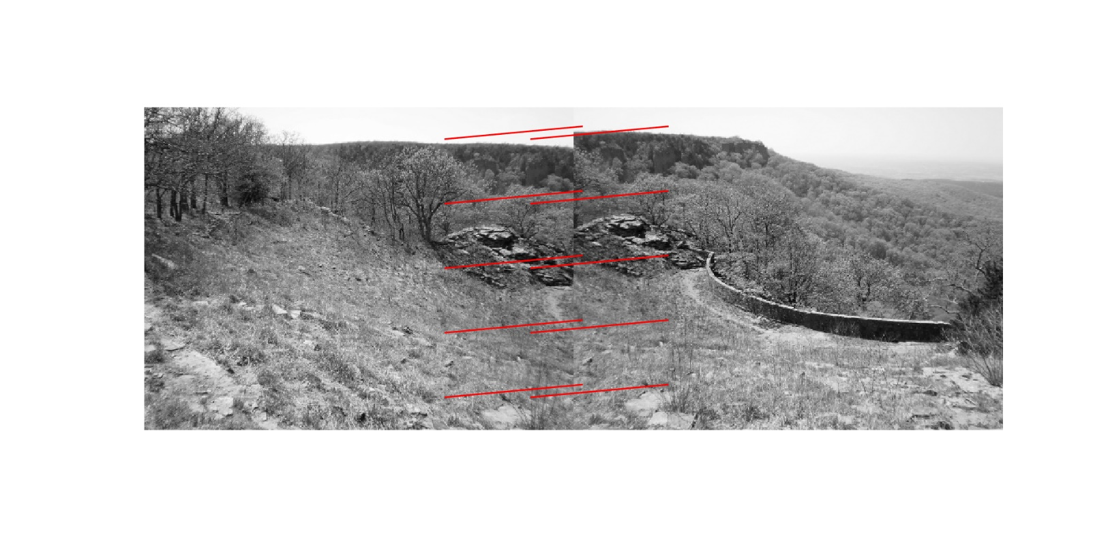

Even though this model is better, we think that the picture not only responds to a linear translation but also to a resize, because it looks like the second picture has been taken from a little bit further from the rocks.

# Panorama creation